Workshop on Modernization of Agriculture for a Prosperous Nepal
(Jestha 21-22, 2078; June 4-5, 2021)
Call for Papers
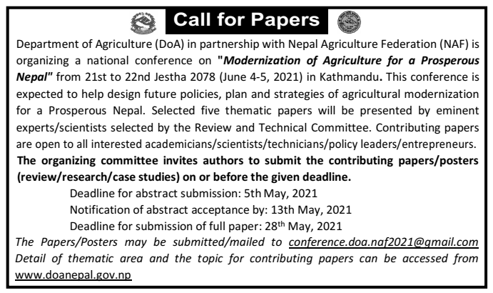
Notice Published in Katnipur Daily (2077-12-31)
Department of Agriculture (DoA) in partnership with Nepal Agriculture Federation (NAF) is organizing a national conference on "Modernization of Agriculture for a Prosperous Nepal" from 21st to 22nd Jestha 2077 (June 4-5, 2021) in Kathmandu. This conference is expected to help design future policies, plan and strategies of agricultural modernization for a Prosperous Nepal.
Selected five thematic papers (Youth engagement in agriculture, Land Bank/ land consolidation for commercialization of agriculture, Risk aversion in agriculture, Contemporary strategy to reform agriculture extension, Foreign direct investment in agriculture), one from each area, will be presented by eminent experts/scientists selected by the Review and Technical Committee. Contributing papers are open to all interested scientists/technicians/policy leaders in the following topics (2-3 papers from each topic).
The organizing committee invites authors to submit the contributing papers/posters (review/research/case studies) on the following topics:
- Research/review papers for increasing production, productivity and modernization of agriculture.
- Agricultural mechanization
- Information and Communication Technology (ICT) in agriculture
- Feminization in agriculture
- Research-Extension-Education linkage
- Precision and protected horticulture
- New agriculture policies for import substitution and export promotion: Strategies, programs and way forward
- Post-COVID agriculture
Deadline for abstract submission: 5th May, 2021
Notification of abstract acceptance by: 13th May, 2021
Deadline for submission of full paper: 28th May, 2021

The Papers/Posters may be submitted/mailed to conference.doa.naf2021@gmail.com
Guidelines to authors for submission of abstract
Submission Options and Descriptions
- Oral Presentation: The selected abstracts will be considered for oral presentation.
- Poster Presentation: The selected abstracts will be considered only for poster presentation.
Required Format for Submissions
- Each submission should include a title, abstract, and keywords in one document.
- Authors' affiliation [name(s) and institution(s) of each author] should be provided below the title. For the lead author only, include contact information (mobile and email address).
- Include up to five keywords at the last part of the abstract.
- Limit your abstract to 250 words (including title, authors' name/affiliation and keywords). The abstract should clearly address the theme under which the abstract is written.
- Font: Times New Roman; Size: 14 for title, 12 for heading and general text. The title and headings should be bold. Line spacing: double spaced.
- Figures and tables are NOT allowed.
- Units of measurement: All units and measures should be in International System of Units (SI system).
- Submissions not meeting these minimum guidelines will be rejected without review.
Submission Instructions
- Save your abstract as a word.doc file.
- Name your word file using this format: [Lastname] 1.doc Example: Ghimire1.doc. If you are submitting more than one abstract, follow the same format and change the number: [Lastname] 2.doc
- The abstract must be submitted electronically by mailing to conference.doa.naf2021@gmail.com on or before 5th May 2021.
- Review Process: Each abstract will be blind-peer reviewed by expert reviewers. The lead author of the abstract will be notified of the review decision via email on or before 13th May, 2021.
- The general guidelines for preparing oral presentations and poster presentations will be posted separately in the website of the Department of Agriculture. www.doanepal.gov.np

Abstract Review Criteria (oral/poster):

Equal weight will be given to each of the following criteria:
- Novelty in approaching, framing, and understanding the thematic area/topic of the workshop;
- Quality of data, methods, analytical rigor;
- Quality of Writing;
- Strength and relevance of expected outcomes of the conference, contribution to the larger literature and knowledge base for modernization of agriculture;
- Integration of research, data, and/or theory with policy, practice, and application

